.

##### PROJECT REPORT

**ON**

###### HOT STAR CLONE

Of

**Bachelor of Technology In**

COMPUTER SCIENCE & ENGINEERING

**Submitted By-**

BHAWANA,

ANUPAMA,

ARVIND KUMAR,

SHIVANI

DEPARTMENT OF COMPUTER SCIENCE & ENGINEERING ECHELON INSTITUTE OF TECHNOLOGY, FARIDABAD

**APRIL 2022 – AUGUST 2022**

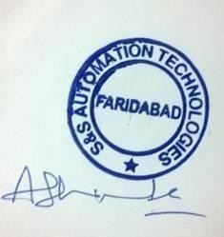



#### CERTIFICATE

I/We hereby certify that the work which is being presented in the B.Tech. Project Report entitled **HOT STAR CLONE** for the award of the Bachelor of Technology in Computer Science & Engineering and submitted to the Department of Computer Science & Engineering of Echelon Institute of Technology, Faridabad is an authentic record of our work carried out during a period from January 2022 to May 2022.

The matter presented in this thesis has not been submitted by us for the award of any other degree elsewhere.

Signature of Candidate-

BHAWNA - 21-CSE-28

ANUPAMA - 21-CSE-19

ARVIND KUMAR- 21-CSE-25

SHIVANI – 22-CSE-L-026



### TO WHOM IT MAY CONCERN

This is to certify that the Project entitled “**HOTSTAR CLONE**” submitted by “**ROHIT** **LAMBA**” (19- CSE- 092) , “SAKSHAM MISHRA” (19-CSE-101)and “SHIVAM PRASAD” Department of Computer Science and Engineering, Echelon Institute of Technology Under YMCA University, Faridabad, for partial fulfillment of the requirements for the degree of Bachelor of Technology in Computer Science & Engineering; is a bonafide record of the work and investigations carried out by him under my supervision and guidance

Signature of HOD Ms. Shefali Madan Head of Department

Signature of the Supervisor Ms. Jagrati Malviya

Assistant Professor

#### ACKNOWLEDGEMENTS

I take this opportunity to thank all those who have helped me in completing the project successfully.

I would like to express my gratitude to **Ms. Jagrati Malviya**, who as my guide/mentor provided me with every possible support and guidance throughout the development of project. This project would never have been completed without her encouragement and support.

I would also like to show my gratitude to **Ms. Shefali Madan,** Head of Department for providing us with well-trained Team members and giving us all the required resources and a healthy environment for carrying out our project work.

ROHIT

SAKSHAM

SHIVAM

### ABSTRACT

#### The project entitled “HOTSTAR CLONE” is an online platform design and developed by using HTML, CSS and JAVA SCRIPT. . Disney+ Hotstar is an online video streaming platform owned by Novi Digital Entertainment Private Limited, a wholly owned subsidiary of Star India Private Limited. Highly evolved video streaming technology and a high attention to quality of experience across devices and platforms, make Disney+ Hotstar the most complete video destination for Over the Top (OTT) video consumers. A Video Experience Like No Other.

**Seamless Video Playback** - Our adaptive video streaming technology ensures that the best possible video quality is played back automatically based on the available bandwidth, therefore making it a great video experience on both mobile networks as well as WiFi internet connections. Our video is optimized to play on mobile networks with inconsistent throughput so that our users don't have to compromise on their experience on the low end , and play HD quality video on the top end of bandwidth availability. Additionally, our users can manually select the quality of video that suits their taste.

**Smart Search** - Content search on Hotstar has been optimized to reduce complexity and delay in accessing content. Accurate search results, with lightning fast autocomplete suggestions navigate users to video with minimal navigation friction and ease of use.

**Friendly User Interface** - Content organization on Hotstar is a result of a thoughtful user experience approach and strong design principles that ensure that the user is not overwhelmed with the breadth of content available. Using a mix of algorithms and human curation, users at any stage of their interaction with Hotstar will discover content and see their experience evolve with their interaction patterns over time.

**Hot Content Catalogue** - Hotstar offers the latest and popular TV, movies and knowledge-based content from India and the world. With content in 8 languages, spanning 15 TV channels, Hotstar is home to some of the longest running, and highest rated TV content in the country. Our roster of the biggest names in Indian cinema make Hotstar the preferred destination for the biggest blockbusters from Bollywood and regional cinema.

**TABLE OF CONTENTS**

Certificate II

Candidate declaration III

Acknowledgement IV

Abstract V

Chapter 1: Introduction to Project 7-10

Chapter 2: Requirement Analysis 11-13

Chapter 3: Language and Libraries used 14-18

Chapter 4: Implementation of components and functions 19-38

Chapter 5: Information about Testing 39-44

Chapter 6: Conclusion 45-46

Chapter 7: References 47-48

Chapter 8: Brief Profile 49-50

**Chapter 1**

**INTRODUCTION TO PROJECT**

Chapter 1 INTRODUCTION TO PROJECT

**WHAT IS HOT STAR?**

On 1st February 2015, a handful of people celebrated on the 27th floor of their office as they had finally launched the project they had been working on for over 15 months called ‘Hotstar’. There was a sense of tension in the room as the team took turns refreshing the analytics page to keep track of the numbers. When the numbers finally arrived, Hotstar had beaten every application in the world to achieve the million mark and literally broke the internet.

Hotstar is a digital and mobile entertainment platform owned by Novi Digital Entertainment, a wholly owned subsidiary of Star India. Hotstar was launched on 1st February 2015 after a month of beta testing during January 2015 (Kamanth, 2016). Hotstar was born as a result of necessity more than an innovation. The necessity came as Star India had different YouTube channels for each broadcasted with over 100,000 hours of content which needed to be segregated as per consumer demands. The consumer wanted to have a variety of content on a single platform with differentiated playlists as per his/her tastes and preferences. **We are very influenced by hotstar model, so we tried to create our own ‘HOTSTAR CLONE’**.

### — Technologies Require for Disney+ Hotstar Clone development

* **HTML**
* **CSS**
* **JAVA SCRIPT**
* **AWS or Azure for Cloud**

**There are two revenue and business models;**

### — Subscription Based

The main source of income of most of the on-demand video streaming services is subscription-based. Users can pay the subscription amount based on the pack that they choose. Disney+ and Hot star offer monthly and yearly subscription for the Premium pack, however, there is only a yearly subscription available for the Hot star VIP pack.

### — Advertisement

As I mentioned earlier, there’s also a free plan on Hot star. It uses advertisements to generate revenue. When you are streaming something in the free version, you will have to see an advertisement in 5-10 minutes interval.

**Features offered by HOT STAR**

**1. Video Library**

**2. Search and explore option**

**3. User profile**

**4. Watchlist**

**5. Privacy Settings**

**6. Multiple languages**

**7. HD video content**

Developing an app like Disney+ and Hotstar will take time around 20 Weeks. The time can also increase depending on your requirements, the features that you choose, and the platform compatibility for Disney+ Hotstar like app development.

**We should remember this is the just the clone of hot star not the full app.**

# CHAPTER 2 REQUIREMENT ANALYSIS

Chapter 2 REQUIREMENT ANALYSIS

PROJECT AIMS:

* 1. Aim is to **make the platform to operate even at as low as 512kbps**. So, great video experience on any bandwidth – even on 3G! It was developed such a way so the application can run on as many as 7,000 operating systems any screen sizes.
  2. To provide the quality content to the users.
  3. To enhance the lifestyle of people.

Software and Hardware Requirements:

A Software requirements specification (SRS) document describes the intended purpose,requirements, and nature of software/application/project to be developed.

1. Visual Studio Code
2. HTML Programming Language
3. CSS Programming Language
4. JavaScript Programming Language
5. CSS Library - BootStrap
6. JavaScript library
7. AWS
8. OS :- Windows/ MacOs / Linux
9. A good CPU (preferably 6 cores)
10. Good amount of RAM (minimum 2 GB)
11. knowledge of basic programming for problem solving

# CHAPTER 3 LANGUAGE AND LIBRARIES USED

Chapter 3

**Language and Libraries used**

HTML:

**What is HTML?**

* HTML stands for Hyper Text Markup Language
* HTML is the standard markup language for creating Web pages
* HTML describes the structure of a Web page
* HTML consists of a series of elements
* HTML elements tell the browser how to display the content
* HTML elements label pieces of content such as "this is a heading", "this is a paragraph", "this is a link", etc.
* The <!DOCTYPE html> declaration defines that this document is an HTML5 document
* The <html> element is the root element of an HTML page
* The <head> element contains meta information about the HTML page
* The <title> element specifies a title for the HTML page (which is shown in the browser's title bar or in the page's tab)
* The <body> element defines the document's body, and is a container for all the visible contents, such as headings, paragraphs, images, hyperlinks, tables, lists, etc.
* The <h1> element defines a large heading
* The <p> element defines a paragraph

CSS:

**What is CSS?**

* CSS stands for Cascading Style Sheets
* CSS describes how HTML elements are to be displayed on screen, paper, or in other media
* CSS saves a lot of work. It can control the layout of multiple web pages all at once
* External stylesheets are stored in CSS files
* **Cascading Style Sheets** (**CSS**) is a [style sheet language](https://en.wikipedia.org/wiki/Style_sheet_language) used for describing the [presentation](https://en.wikipedia.org/wiki/Presentation_semantics) of a document written in a [markup language](https://en.wikipedia.org/wiki/Markup_language) such

as [HTML](https://en.wikipedia.org/wiki/HTML) or [XML](https://en.wikipedia.org/wiki/XML) (including XML dialects such as SVG, MathML or

XHTML).[[1]](https://en.wikipedia.org/wiki/CSS#cite_note-1) CSS is a cornerstone technology of the [World Wide Web](https://en.wikipedia.org/wiki/World_Wide_Web), alongside HTML and [JavaScript](https://en.wikipedia.org/wiki/JavaScript).[[2]](https://en.wikipedia.org/wiki/CSS#cite_note-2)

CSS is designed to enable the separation of presentation and content, including [layout](https://en.wikipedia.org/wiki/Page_layout), [colors](https://en.wikipedia.org/wiki/Color), and [fonts](https://en.wikipedia.org/wiki/Typeface).[[3]](https://en.wikipedia.org/wiki/CSS#cite_note-3) This separation can improve

content [accessibility](https://en.wikipedia.org/wiki/Accessibility); provide more flexibility and control in the specification of presentation characteristics; enable multiple [web pages](https://en.wikipedia.org/wiki/Web_page) to share formatting by specifying the relevant CSS in a separate .css file, which reduces complexity and repetition in the structural content; and enable the .css file to be [cached](https://en.wikipedia.org/wiki/Cache_(computing)) to improve the page load speed between the pages that share the file and its formatting.

* Separation of formatting and content also makes it feasible to present the same markup page in different styles for different rendering methods, such as on- screen, in print, by voice (via speech-based browser or [screen reader](https://en.wikipedia.org/wiki/Screen_reader)), and

on [Braille-based](https://en.wikipedia.org/wiki/Braille_display) tactile devices. CSS also has rules for alternate formatting if the content is accessed on a [mobile device](https://en.wikipedia.org/wiki/Mobile_device).[[4]](https://en.wikipedia.org/wiki/CSS#cite_note-4)

* The name *cascading* comes from the specified priority scheme to determine which style rule applies if more than one rule matches a particular element. This cascading priority scheme is predictable.

Javascript:

**What is JavaScript?**

* JavaScript was initially created to “make web pages alive”.
* The programs in this language are called scripts. They can be written right in a web page’s HTML and run automatically as the page loads.
* Scripts are provided and executed as plain text. They don’t need special preparation or compilation to run.
* In this aspect, JavaScript is very different from another language called Java.
* Modern JavaScript is a “safe” programming language. It does not provide low- level access to memory or CPU, because it was initially created for browsers which do not require it.
* JavaScript’s capabilities greatly depend on the environment it’s running in. For instance, Node.js supports functions that allow JavaScript to read/write arbitrary files, perform network requests, etc.
* In-browser JavaScript can do everything related to webpage manipulation, interaction with the user, and the webserver.

For instance, in-browser JavaScript is able to:

* Add new HTML to the page, change the existing content, modify styles.
* React to user actions, run on mouse clicks, pointer movements, key presses.
* Send requests over the network to remote servers, download and upload files (so- called AJAX and COMET technologies).
* Get and set cookies, ask questions to the visitor, show messages.

**AWS-**

**Amazon Web Services, Inc.** (**AWS**) is a subsidiary of [Amazon](https://en.wikipedia.org/wiki/Amazon.com) that provides [on-demand](https://en.wikipedia.org/wiki/Software_as_a_service) [cloud computing](https://en.wikipedia.org/wiki/Cloud_computing) [platforms](https://en.wikipedia.org/wiki/Computing_platform) and [APIs](https://en.wikipedia.org/wiki/Application_programming_interface) to individuals, companies, and governments, on a metered pay-as-you-go basis. These cloud computing [web services](https://en.wikipedia.org/wiki/Web_services) provide [distributed computing](https://en.wikipedia.org/wiki/Distributed_computing) processing capacity and software tools via AWS [server farms](https://en.wikipedia.org/wiki/Server_farms). One of these services is [Amazon Elastic Compute Cloud](https://en.wikipedia.org/wiki/Amazon_Elastic_Compute_Cloud) (EC2), which allows users to have at their disposal a [virtual](https://en.wikipedia.org/wiki/Virtualization) [cluster of computers](https://en.wikipedia.org/wiki/Computer_cluster), available all the time, through the Internet.

Amazon markets AWS to subscribers as a way of obtaining large-scale computing capacity more quickly and cheaply than building an actual physical server farm.[[10]](https://en.wikipedia.org/wiki/Amazon_Web_Services#cite_note-12) All services are billed based on usage, but each service measures usage in varying ways. As of 2021 Q4, AWS has 33% market share for cloud infrastructure while the next two competitors [Microsoft Azure](https://en.wikipedia.org/wiki/Microsoft_Azure) and [Google Cloud](https://en.wikipedia.org/wiki/Google_Cloud_Platform) have 21%, and 10% respectively, according to Synergy Group.

Key components of AWS used:-

**1) AWS EC2 :-** Amazon Elastic Compute Cloud (Amazon EC2) offers the broadest and deepest compute platform, with over 500 instances and choice of the latest processor, storage, networking, operating system, and purchase model to help you best match the needs of your workload. We are the first major cloud provider that supports Intel, AMD, and Arm processors, the only cloud with on-demand EC2 Mac instances, and the only cloud with 400 Gbps Ethernet networking. We offer the best price performance for machine learning training, as well as the lowest cost per inference instances in the cloud. More SAP, high performance computing (HPC), ML, and Windows workloads run on AWS than any other cloud.

**2) AWS S3:-** Amazon Simple Storage Service (Amazon S3) is an object storage service offering industry-leading scalability, data availability, security, and performance. Customers of all sizes and industries can store and protect any amount of data for virtually any use case, such as data lakes, cloud-native applications, and mobile apps. With cost-effective storage classes and easy-to-use management features, you can optimize costs, organize data, and configure fine-tuned access controls to meet specific business, organizational, and compliance requirements.

**3) AWS Elastic IP:-** An Elastic IP address is a static IPv4 address designed for dynamic cloud computing. An Elastic IP address is allocated to your AWS account, and is yours until you release it. By using an Elastic IP address, you can mask the failure of an instance or software by rapidly remapping the address to another instance in your account. Alternatively, you can specify the Elastic IP address in a DNS record for your domain, so that your domain points to your instance. For more information, see the documentation for your domain registrar, or [Set up dynamic DNS on Your Amazon Linux instance](https://docs.aws.amazon.com/AWSEC2/latest/UserGuide/dynamic-dns.html).

An Elastic IP address is a public IPv4 address, which is reachable from the internet. If your instance does not have a public IPv4 address, you can associate an Elastic IP address with your instance to enable communication with the internet. For example, this allows you to connect to your instance from your local computer.

**4)** **AWS IAM:-** With AWS Identity and Access Management (IAM), you can specify who or what can access services and resources in AWS, centrally manage fine-grained permissions, and analyze access to refine permissions across AWS.

**SSH CLINT-**

SSH, also known as Secure Shell or Secure Socket Shell, is a network protocol that gives users, particularly system administrators, a secure way to access a computer over an unsecured network.

SSH also refers to the suite of utilities that implement the SSH protocol. Secure Shell provides strong password [authenticatio](https://www.techtarget.com/searchsecurity/definition/authentication)n and [public ke](https://www.techtarget.com/searchsecurity/definition/public-key)y authentication, as well as [encrypte](https://www.techtarget.com/searchsecurity/definition/encryption)d data communications between two computers connecting over an open network, such as the internet.

Secure Shell was created to replace insecure terminal emulation or login programs, such as[Telnet](https://www.techtarget.com/searchnetworking/definition/Telnet), [login](https://www.techtarget.com/searchnetworking/definition/rlogin)(remote login) and RSH (remote shell). SSH enables the same functions -- logging in to and running terminal sessions on remote systems. SSH also replaces file transfer programs, such as File Transfer Protocol (FTP) and rcp (remote copy).

**APACHE-**

The Apache HTTP Server Project is an effort to develop and maintain an open-source HTTP server for modern operating systems including UNIX and Windows. The goal of this project is to provide a secure, efficient and extensible server that provides HTTP services in sync with the current HTTP standards.

The Apache HTTP Server ("httpd") was launched in 1995 and it has been the most popular web server on the Internet since April 1996. It has celebrated its 25th birthday as a project in February 2020.

Apache is the most widely used webserver software and runs on 67% of all websites in the world. Developed and maintained by [Apache Software Foundation](https://www.apache.org/), Apache is [open](https://www.wpbeginner.com/glossary/open-source/) source software and available for free.

It’s fast, reliable, and secure. And Apache can be highly customized to meet the needs of many different environments by using extensions and modules.

Most WordPress hosting providers use Apache as their webserver software. However, WordPress can run on other webserver software as well.

**Linux Terminal-**

The Linux terminal is a text-based interface used to control a Linux computer. It's just one of the many tools provided to Linux users for accomplishing any given task, but it's widely considered the most efficient method available. Outside of writing code, it's certainly the most direct method possible. It's so popular, in fact, that Apple changed its foundation to Unix and has gained the [Bash and Z shell](https://opensource.com/business/16/3/top-linux-shells), and Microsoft developed [PowerShell](https://opensource.com/article/18/2/powershell-people), its very own open source command line.

**Amazon Linux 2-**

Amazon Linux 2 is a Linux operating system from Amazon Web Services (AWS). It provides a security-focused, stable, and high-performance execution environment to develop and run cloud applications. Amazon Linux 2 is provided at no additional charge. AWS provides ongoing security and maintenance updates for Amazon Linux 2.

Amazon Linux 2 is provided at no additional charge. Standard Amazon EC2 and AWS charges apply for running Amazon EC2 instances and other services.

**CHAPTER 4**

**IMPLEMENTATION OF COMPONENTS And FUNCTIONS**

Chapter 4

**Implementation of Components and Functions**

Components are independent and reusable bits of code. They serve the same purpose as JavaScript functions, but work in isolation and return HTML.

Components come in two types, Class components and Function components, in this tutorial we will concentrate on Function components.

Class Component:

A class component must include the extends the Component statement. This statement creates an inheritance to React. Component, and gives your component access to React. Component's functions.

The component also requires a render() method, this method returns HTML.

Function Component:

A Function component also returns HTML, and behaves much the same way as a Class component, but Function components can be written using much less code, are easier to understand, and will be preferred in this tutorial.

function Car() {

return <h2>Hi, I am a Car!</h2>;

**CODE**

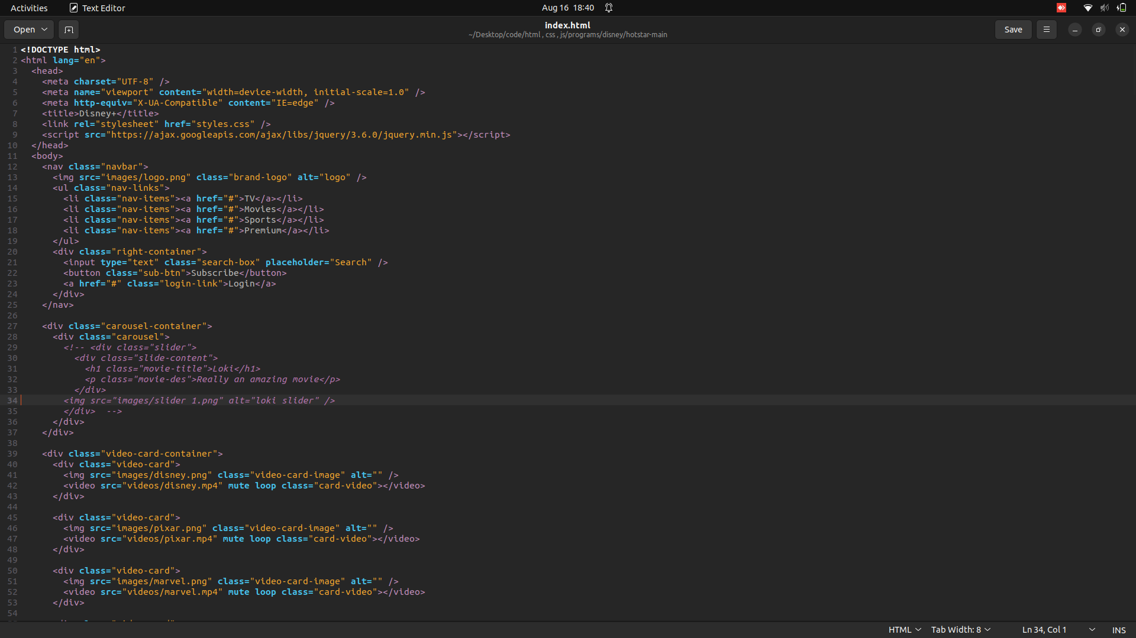

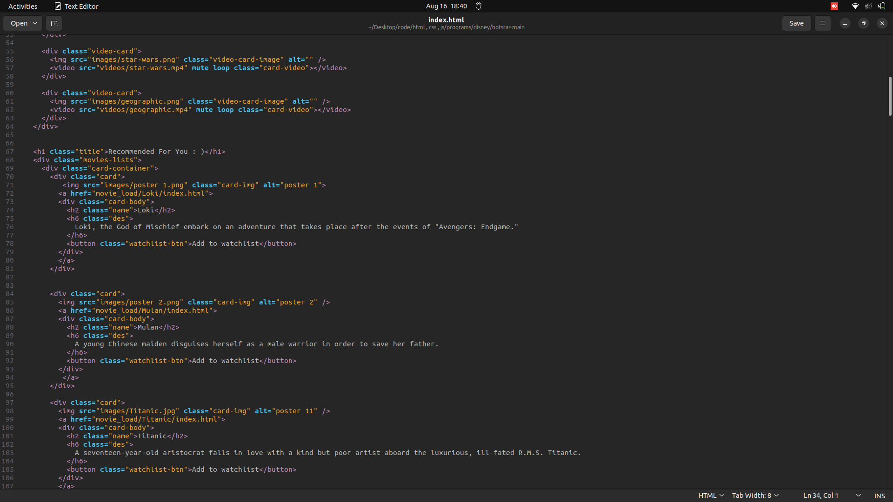

.

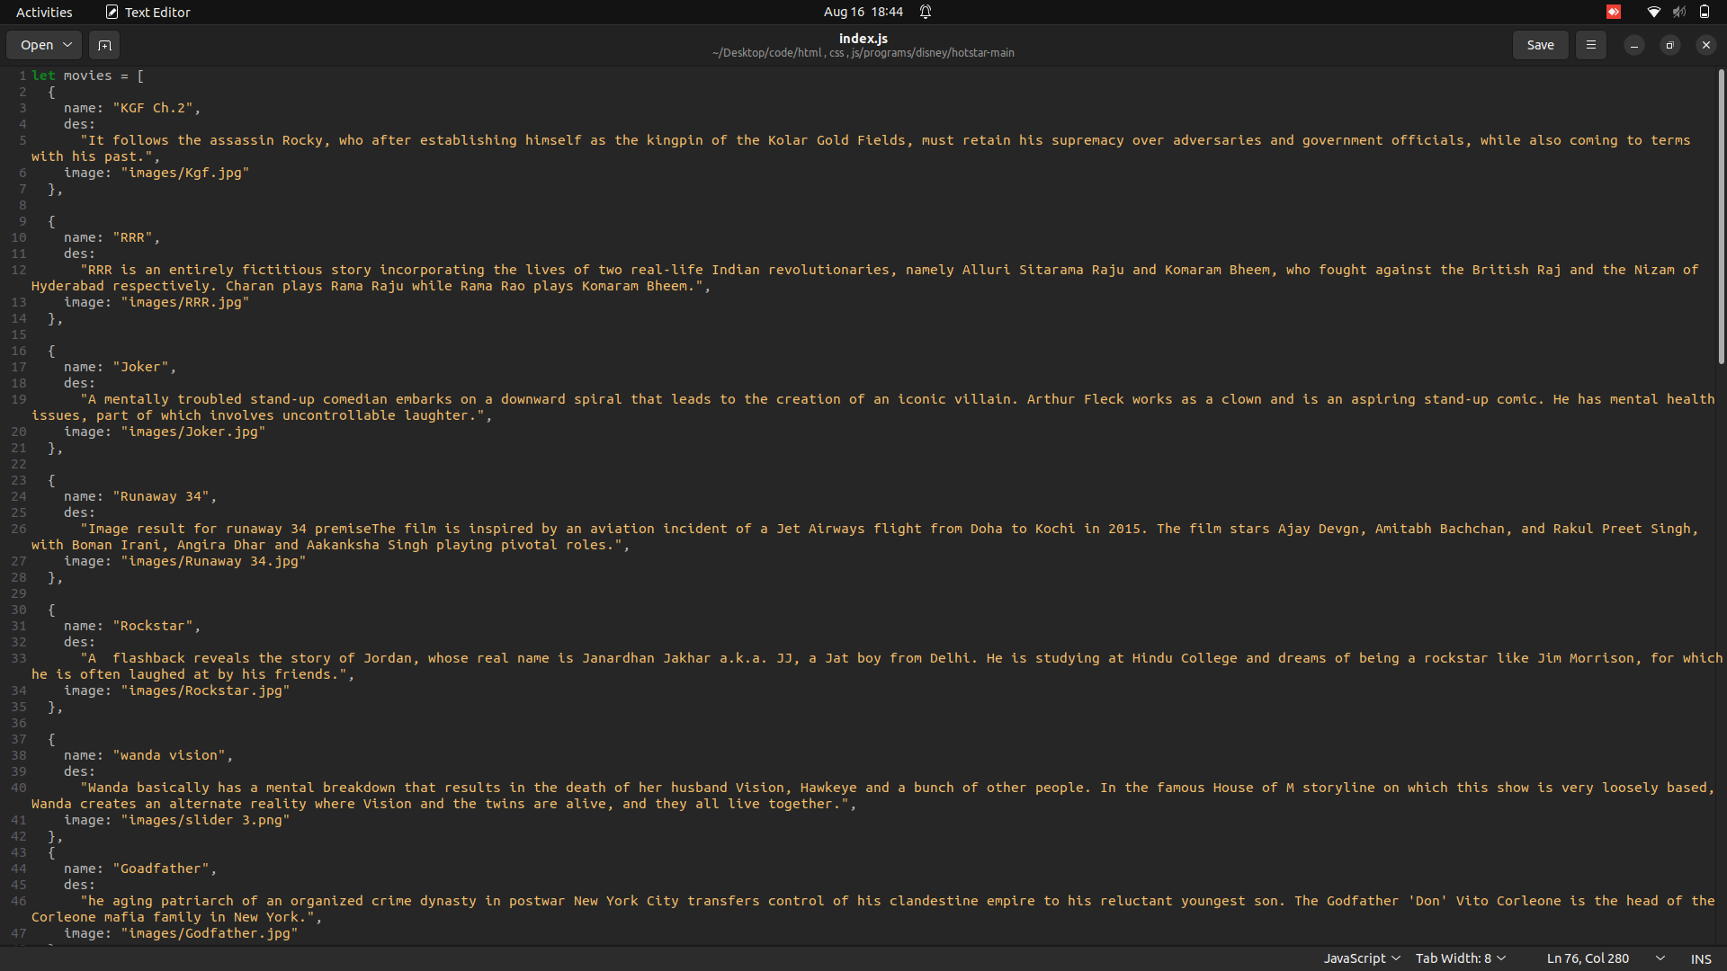

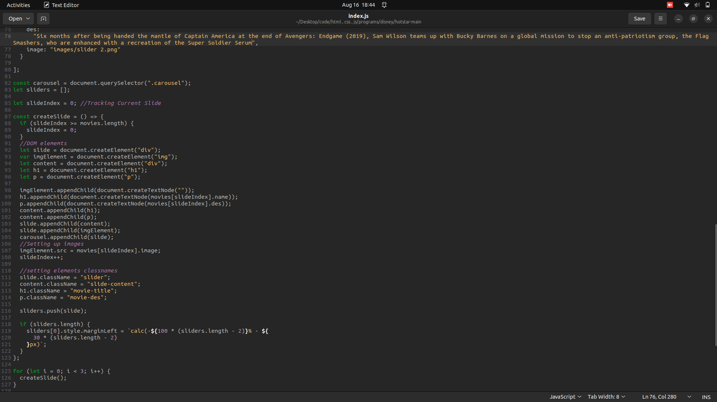

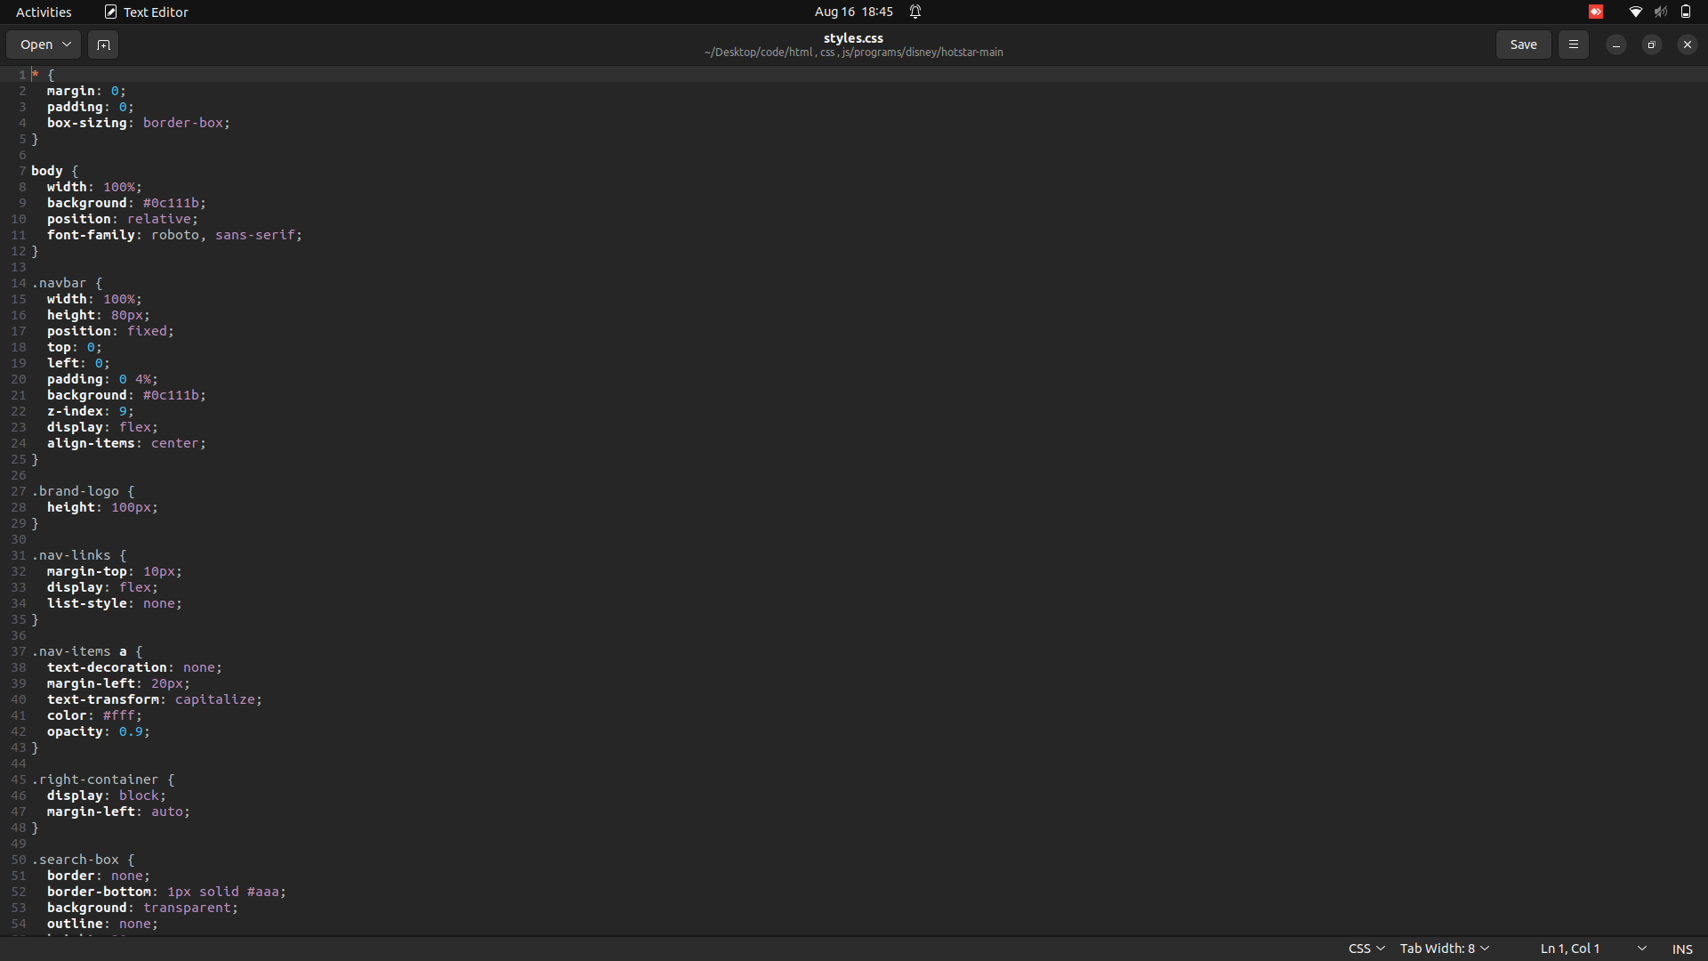

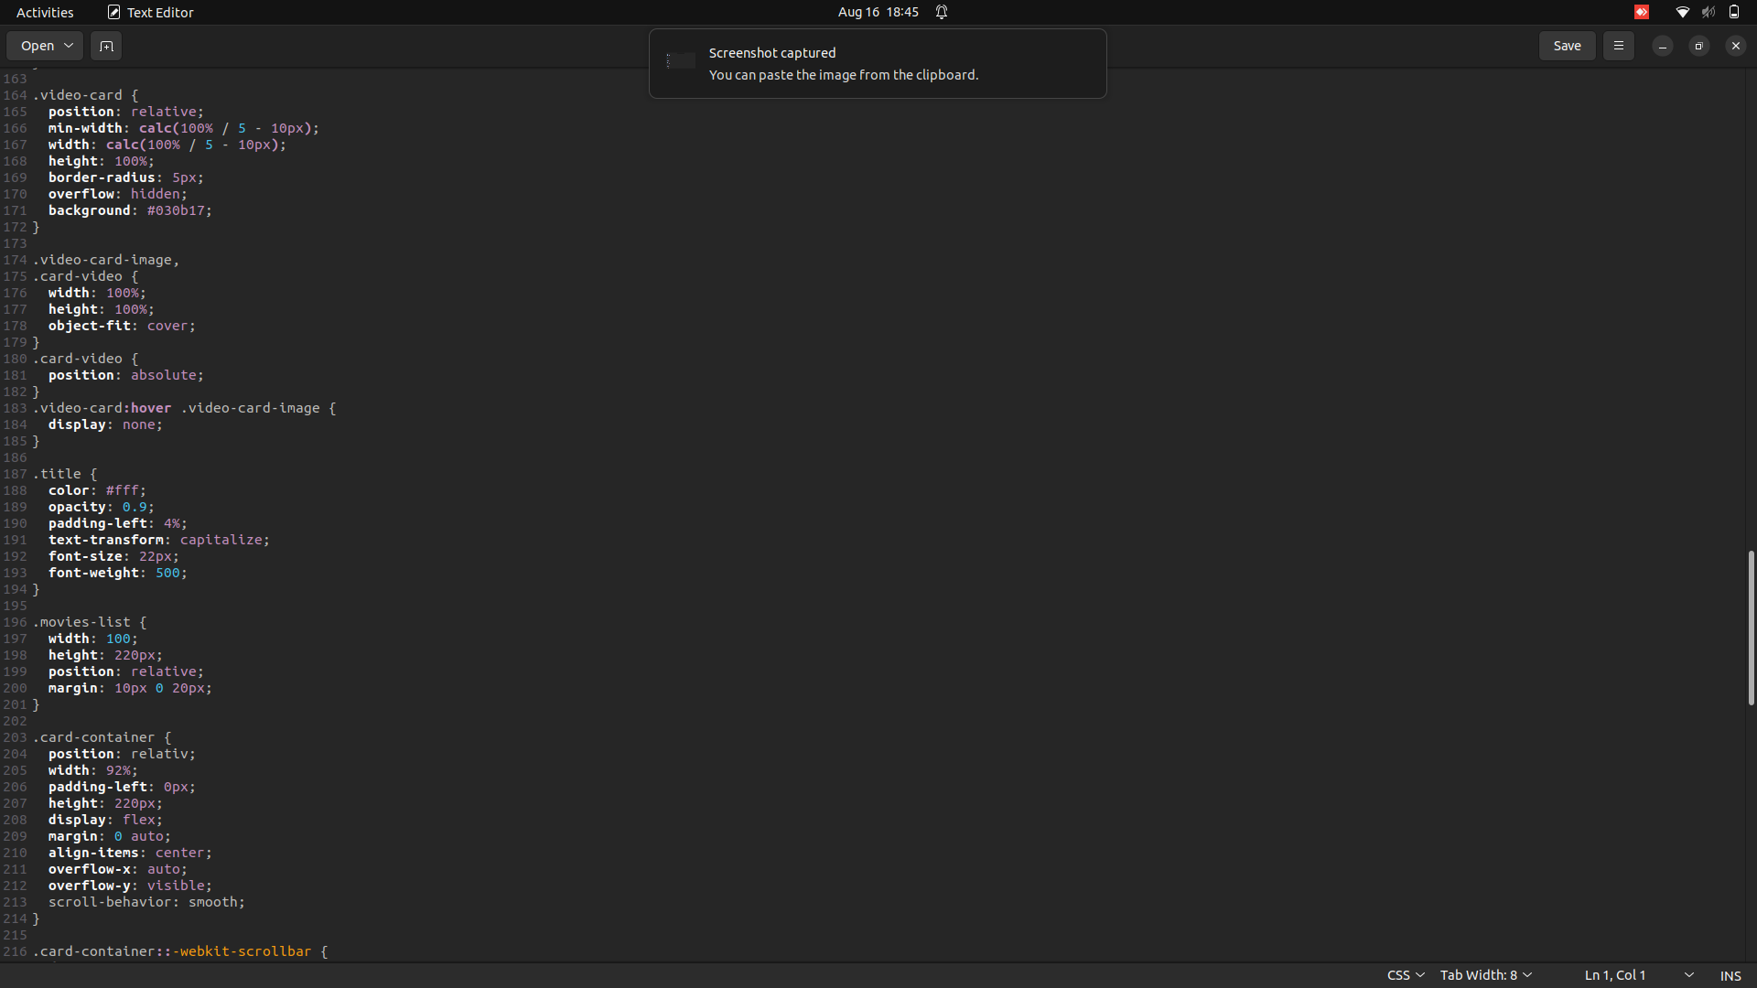

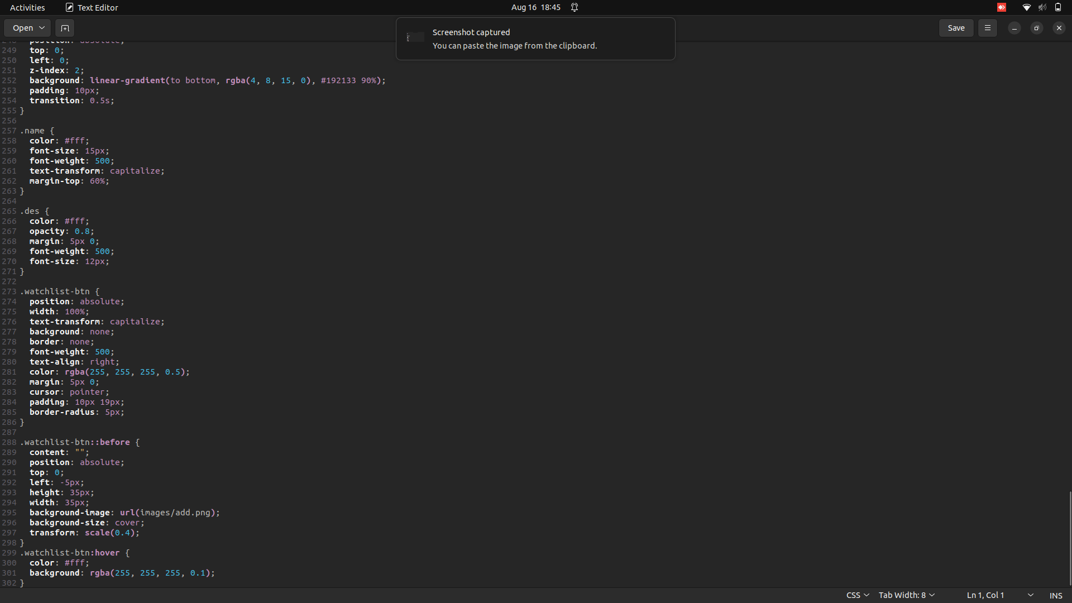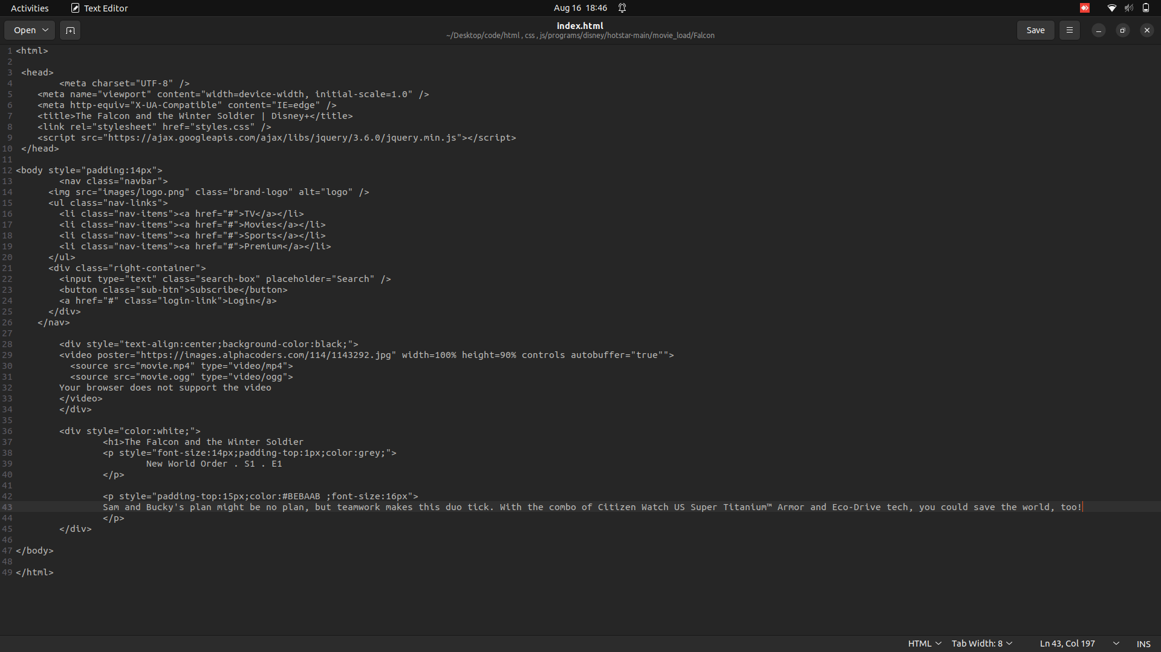

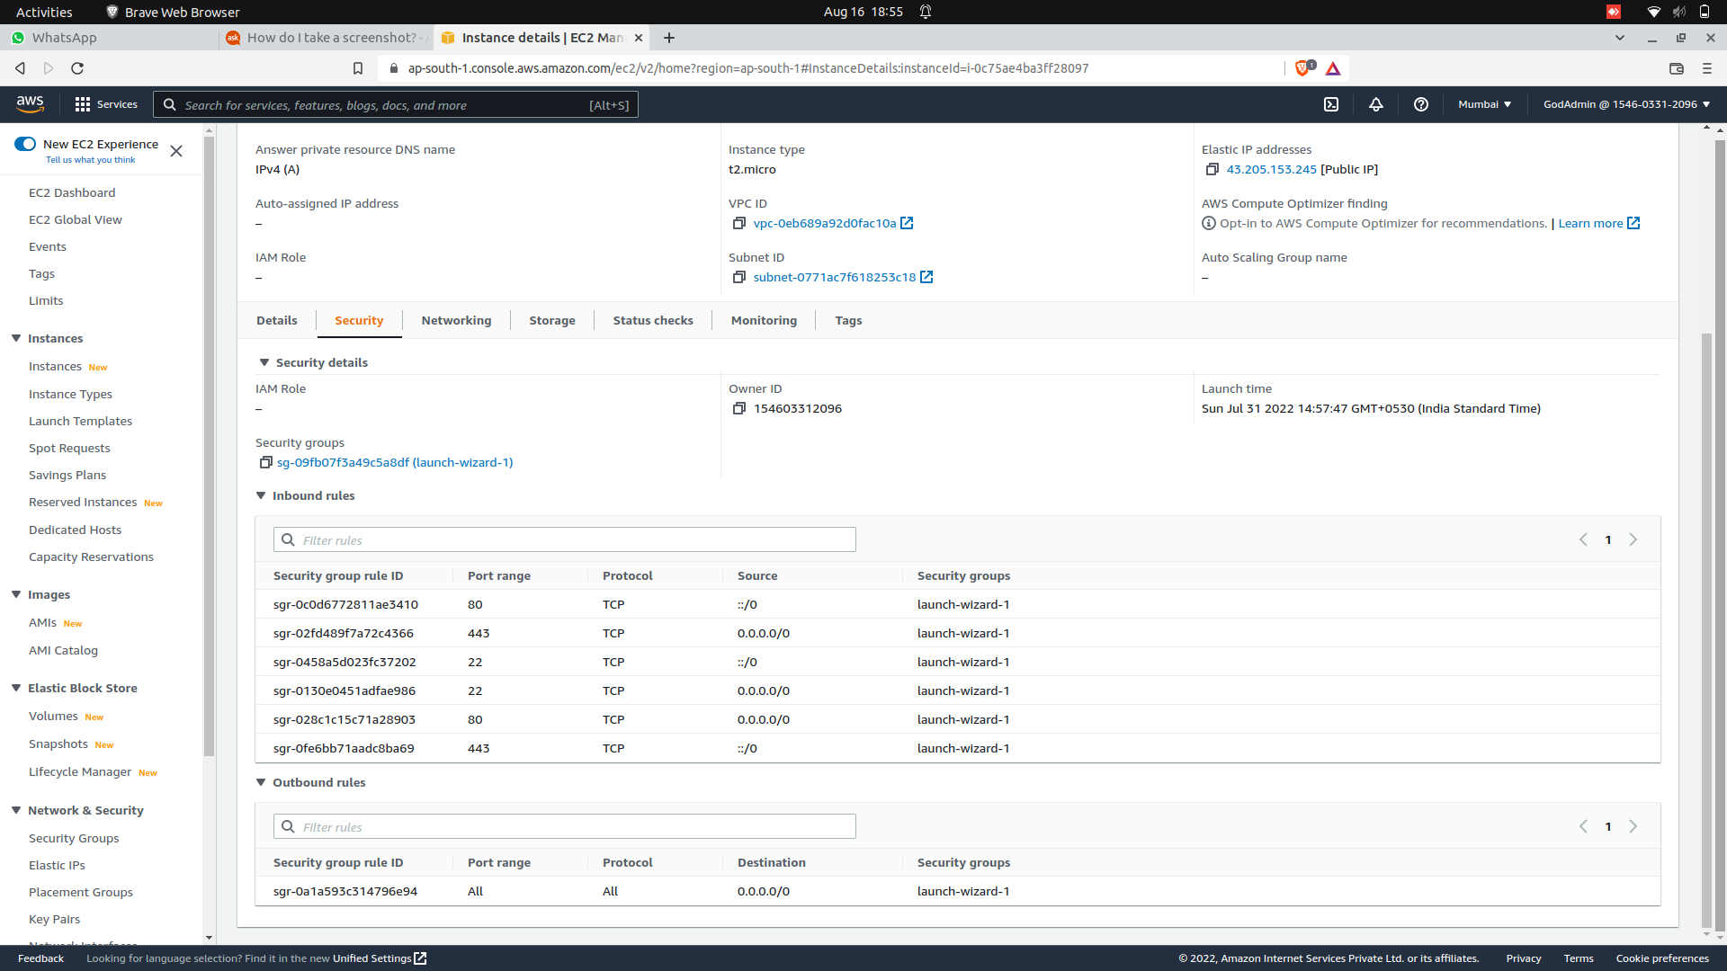

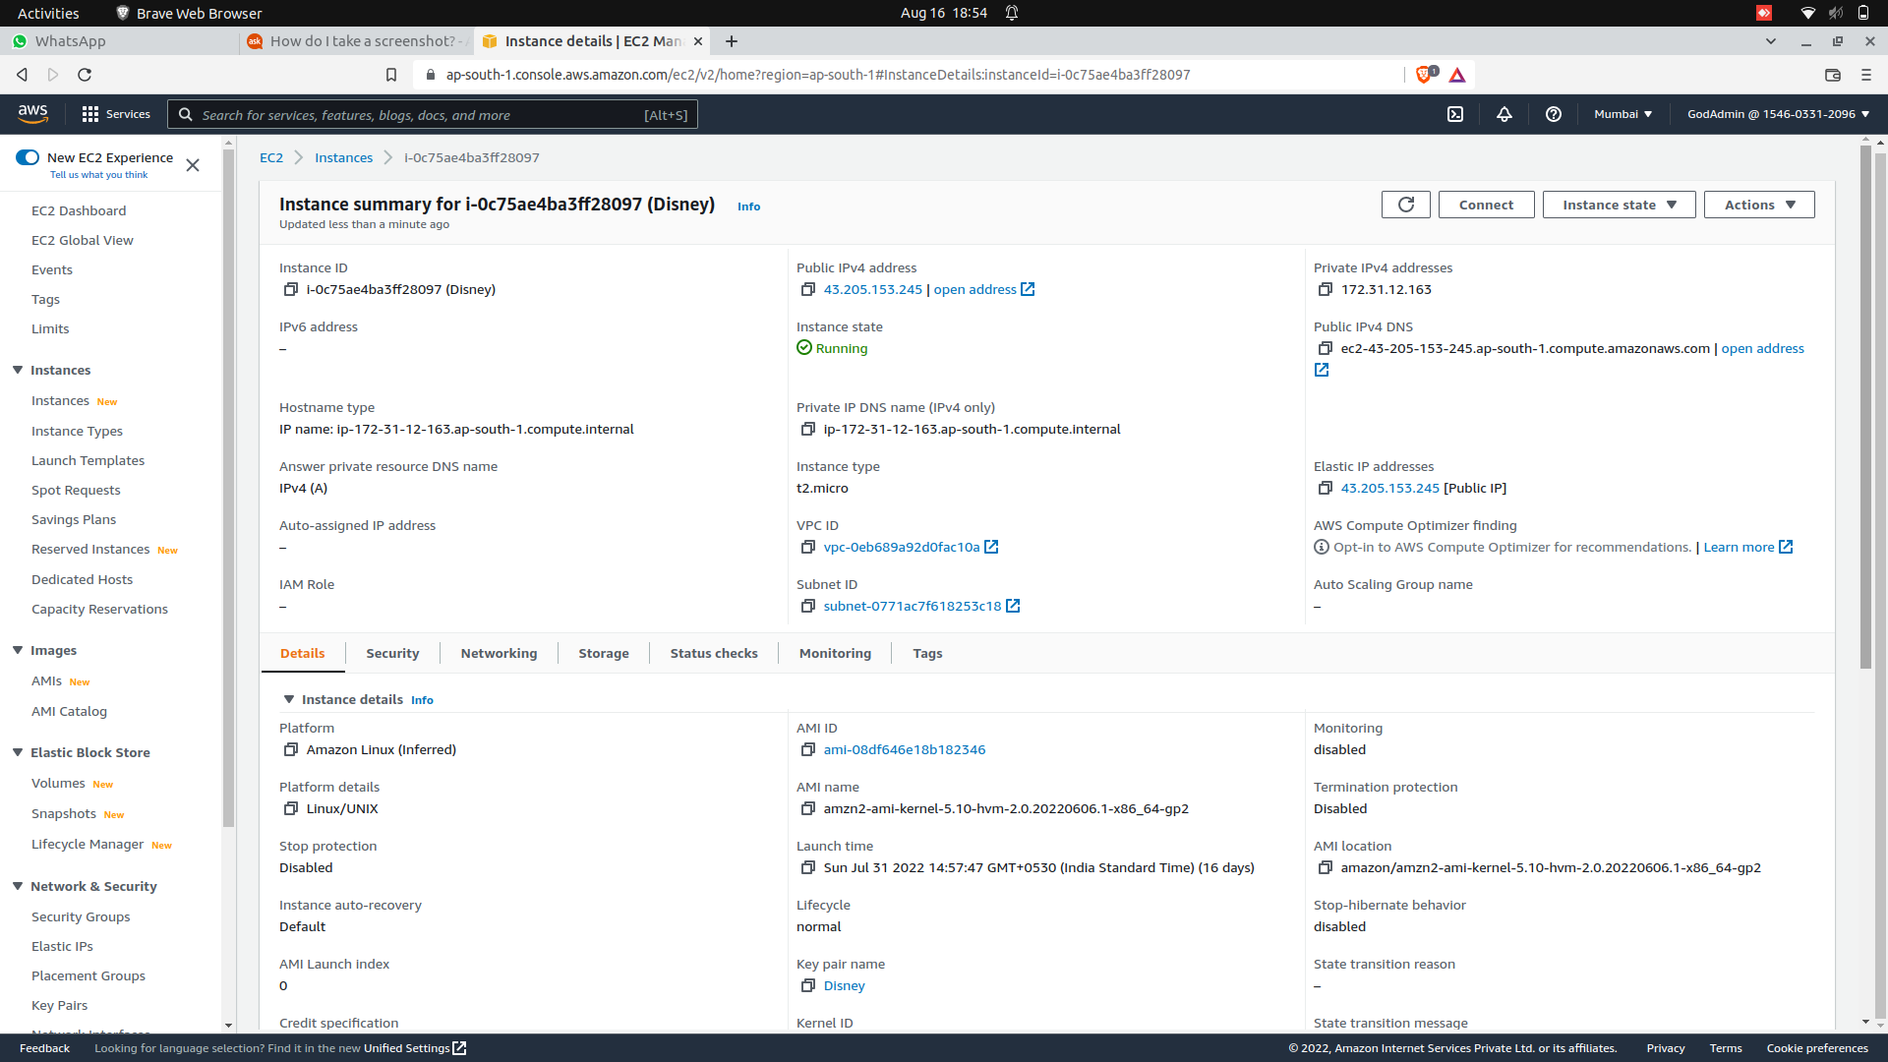

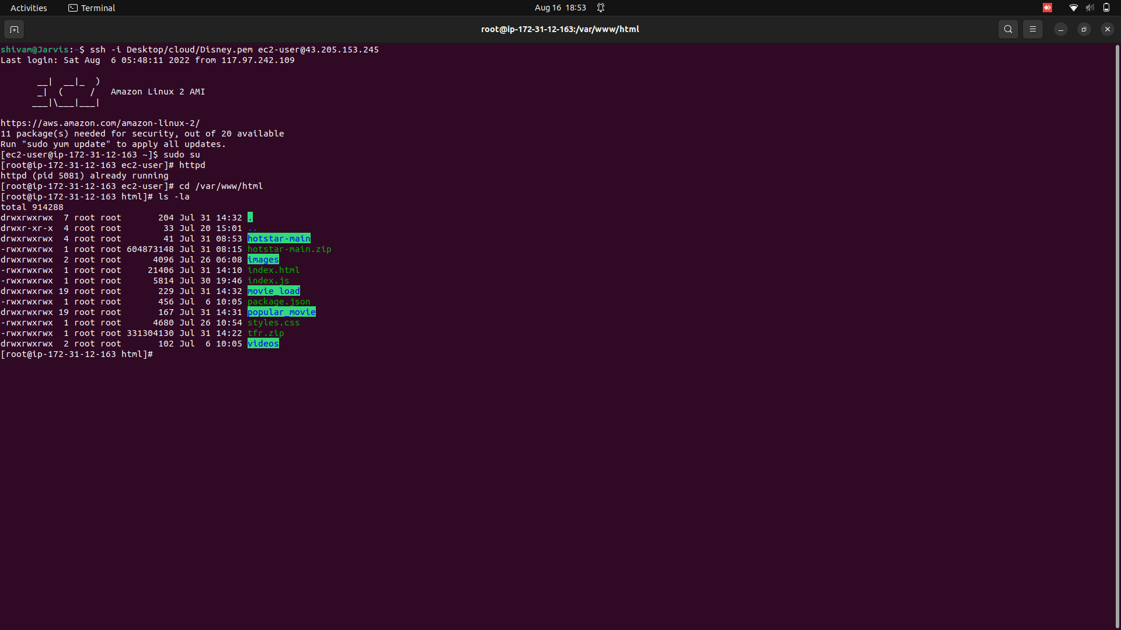

OUTPUT

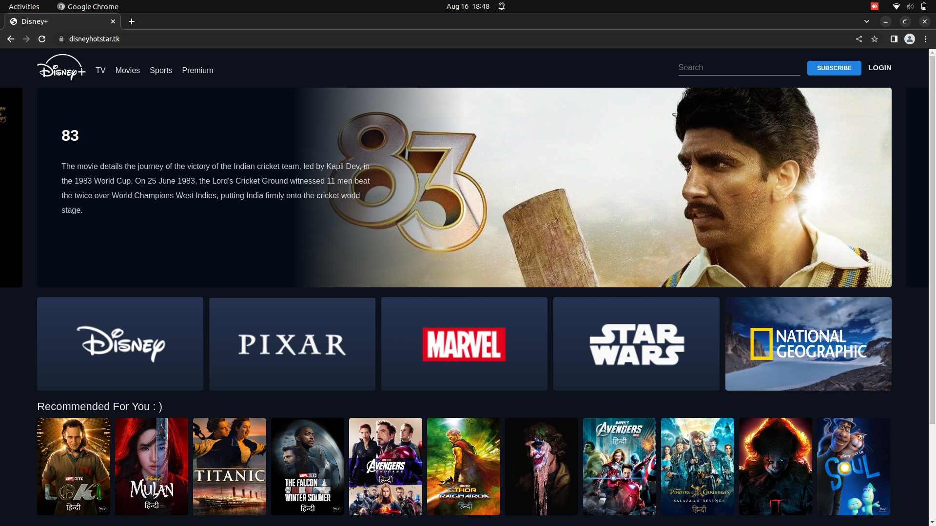

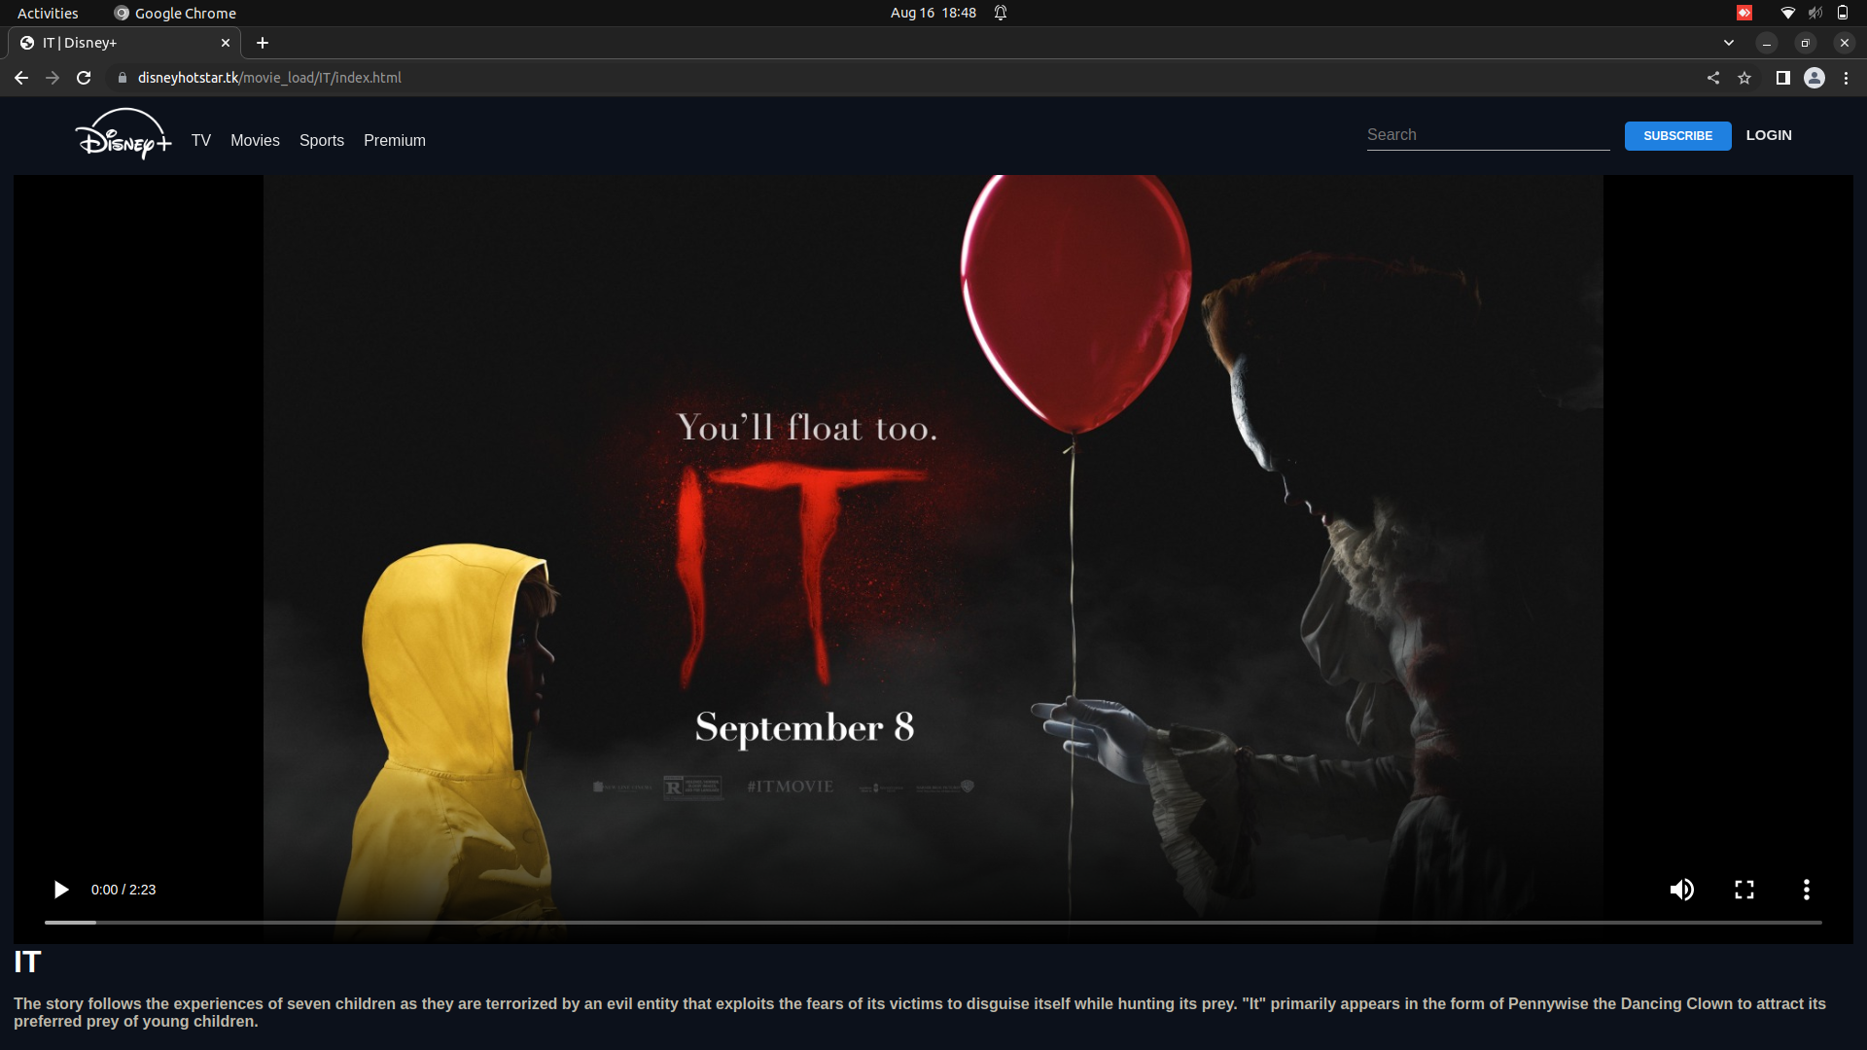

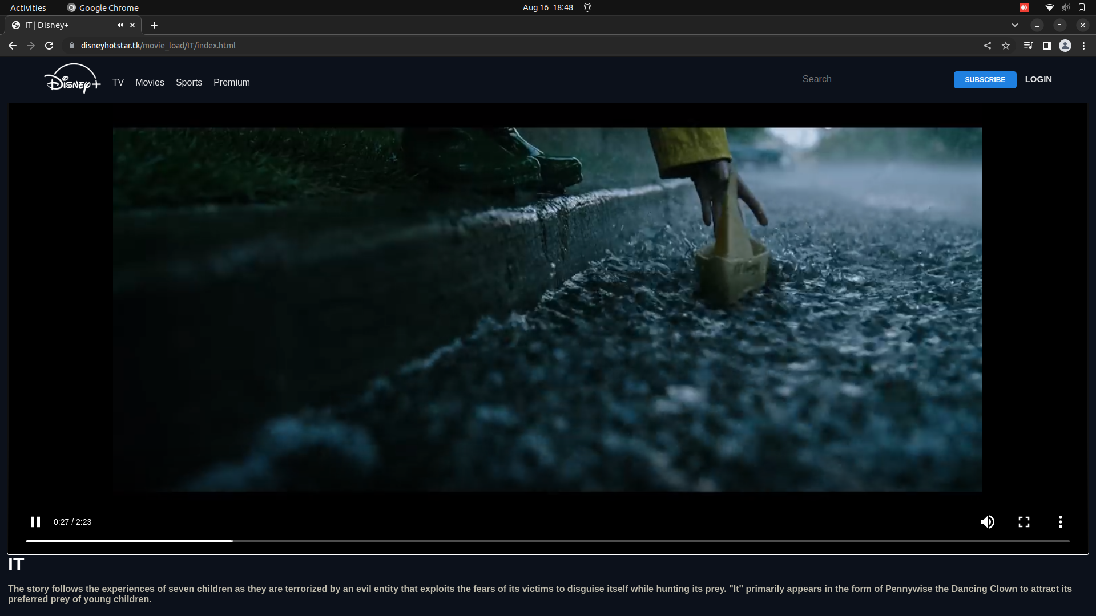

**CHAPTER 5**

**INFORMATION ABOUT TESTING STRATEGY**

Chapter 5

**INFORMATION ABOUT TESTING STRATEGY**

The testing of software means measuring or accessing the software to determine the quality. Testingis a measuring instrument for software quality with the unit of measurement being the number of defects found during testing.

Testing activities also help to achieve software quality. Testing is essential in the development of any system software. Testing is essential in the development of any software system.Testing is in order to access what the system actually does and how well expected to spend approximately 40% of development cost and time in testing in order to achieve reasonable quality levels.

**Levels of Testing**

* Unit Testing
* Component Integration Testing
* System Testing
* Acceptance Testing

**Unit Testing**

Unit testing comprises the set of tests performed usually by the programmers prior to the integration of the unit in to a large Program. This is the lowest level of testing and is done by the programmer (Who develops it) who can test it in great detail. The function is done in isolation. Thisis where the most detailed investigation of internal working of the individual unit is carried out.

**Component Integration Testing**

When two or more tested components are combined into a larger structure, the testingprocess should look for errors in two ways:-

* + In the interface between the components
  + The functions, which can be performed by the new group

**System Testing**

After in integration testing is completed, the entire system is tested as whole. The functionalspecifications or requirements specification are used to derive the test case. At this level the systemtesting looks for errors in the end-to-end functional quality. Attributes such as performance, reliability,

Volume, stress tolerance, usability, maintainability, security etc. Independent testers can carry outthis testing.

**Acceptance Testing**

After system testing was complete, the system was handed over to the training section. Acceptance testing mark the transaction from ownership by the develop to ownership by the users.The acceptance test is different in nature to the development testing in three ways.

Firstly, it is a responsibility of the accepting section rather than development department (computer Centre).

Secondly, the purpose of the acceptance testing was to find out whether the software is working rather than trying to find errors.

Thirdly, it also includes the testing of user’s department’s working practices to ensure thatthe computer software will fit into clerical & administrative procedures of the concerned section well.

Acceptance testing gave confidence to the user that the system is ready for operational

use.

Security concern of computer where software is to be installed:

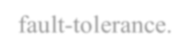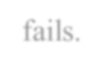

Use of name-brand hardware with extensive fault-tolerance. Fault-tolerance features can keep the computer from going down even if a single piece of hardware inside of it fails.

Hardware and software maintenance.

Facility security, network security, and firewall services.

41



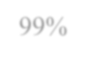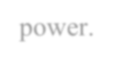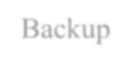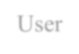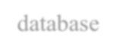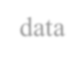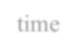

Guaranteed service level agreement. Remember to insist on the highest level of service available – 99% availability might seem great, but it means that our computer might be down for than three days a year.

Battery and generator power.

Backup devices like tap drive/zip drive or cd writer should install. User should keep backup

of database every day so that it could save data during crisis time

**Protecting the database**

To secure the database, the following steps are taken:-

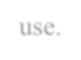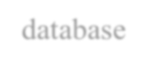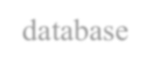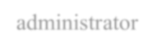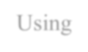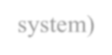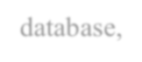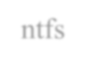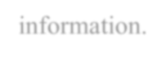

The server logged off and physically locked up when it has not use.

The database must be not shared on network. If it is shared then change the properties. The database on oracle provides fine-grained permission mechanism that allows protecting particular database tables and columns. The table and column must be the restricted to administrator of database so that it is not update by the any one.

Using NTFS (NT file system) security to further access to the database, it is used by using ntfs permission dialog to further protect sensitive information.

**TESTING OBJECTIVES**

No bugs blocks the execution of tasksSystem states are visible

All factors affecting the output are visibleFunctional simplicity

Distinct output is generated for each input

**TEST REPORTS**

**Debugging**

Debugging occurs as a consequence of successful testing. Debugging refers to the process ofidentifying the cause for defective behavior of a system and addressive that

problem. In less complex terms- fixing a bug. When a test case uncovers an Error, debugging is the process that results in the removal of the error. The debugging process beginswith the execution of a test case. The debugging process attempts to match symptoms with cause, thereby leading to error correction. The following are two alternative outcomes of the debugging:

the cause will be found and necessary action such as correction or removal will be taken.The cause will not be found.

**Characteristics of bugs**

* 1. The symptoms ant the cause may be geographically remote. That is, the symptoms may appear in one part of a program. While the cause may actually be located at a site that is far removed. Highly coupled program structures exacerbate this situation.
  2. The symptoms may disappear (temporarly) when another error is connected.
  3. the Symptom may actually be caused by non error(e.g, round-Off inaccuracies).
  4. The symptoms may be caused by human error that is not easily traced.
  5. The symptom may be a result of timing problems, rather than processing problems.
  6. It may be difficult to accurately reproduce input conditions(e.g, a real-time applicationin which input ordering is indeterminate).
  7. The symptom may be intermittent. This is particularly common in embedded systemsthat couple hardware and software inextricably.
  8. The symptoms may be due to causes that are distributed across a number of tasksrunning on different processors.

SYSTEM SECURITY MEASURES

To do an adequate job on security, a systems analyst must analyze the risk, exposure, and costs and specify measures such as passwords and encryption to provide protection. The backup copiesof software and recovery restart procedures must be available when needed.

**SECURITY AGAINST UNAUTHORIZED ACCESS:**

1. *Use of administrator passwords: The password provides security to the administratorof Associates user so that unauthorized user can not access the facility of Associates User.*
2. User related checks and validations: For this software, The developer uses user relatedchecks and validations from the user.
3. User authorization keys: Password checking for logging of Users

**User Level:**

User are does not change Health, Transport Information. Its only View Information and it’s allowed after fill own profile and then insert username and password. User is sending Matrimonialinformation view any other user by allow administrator.

**Administrator Level:**

Administrator is able to change Health, Transport Information. Administrator is allowing matrimonial information any Change. And also allow user view bride picture and groom picture information.

# CHAPTER 6 CONCLUSION

Chapter 6 CONCLUSION

**CONCLUSION:**

The world is going to be more digital, and digitization is the need of every business, every Industry. Hotstar was an angular.js (basic front-end Javascript for building single-page web-based apps) based website with major crawling issues. It aimed to rank for **non-brand queries** with a limited amount of content. Queries that had “streaming”, “score”, “cricket” keywords in them were targeted because of the fantastic sports live streaming features they had obtained. Branded search terms such as “hotstar ipl match live”

**CHAPTER 7 REFERENCES**

**Chapter 7 REFERENCE**

##### REFERENCES

* [**https://web.dev/learn/css/**](https://web.dev/learn/css/)
* **https://www.javatpoint.com/javascript-tutorial**
* [**https://www.geeksforgeeks.org/**](https://www.geeksforgeeks.org/)
* [**https://www.devtown.in/**](https://www.devtown.in/)
* **https://www.hotstar.com/in**

## CHAPTER 8 BRIEF PROFILE

**063**

**Chapter 8**

**BRIEF PROFILE**

We ROHIT, SAKSHAM, SHIVAM students of B. Tech Computer Science and Engineering, have created the above project report during 6th semester on the title **HOTSTAR CLONE** for the partial fulfillment of award for B. Tech Degree. Highlights of the project, my project includes-

* Use of JavaScript which is a General Purpose Programming Language, programmed using the Visual Studio Code.
* USE of html HTML uses "markup" to annotate text, images, and other content for display in a Web browser. HTML markup includes special "elements" such as [<head>](https://developer.mozilla.org/en-US/docs/Web/HTML/Element/head), [<title>](https://developer.mozilla.org/en-US/docs/Web/HTML/Element/title), [<body>](https://developer.mozilla.org/en-US/docs/Web/HTML/Element/body), [<header>](https://developer.mozilla.org/en-US/docs/Web/HTML/Element/header), [<footer>.](https://developer.mozilla.org/en-US/docs/Web/HTML/Element/footer)
* USE of CSS **Cascading Style Sheets** (**CSS**) is a [stylesheet](https://developer.mozilla.org/en-US/docs/Web/API/StyleSheet) language used to describe the presentation of a document written in [HTML](https://developer.mozilla.org/en-US/docs/Web/HTML) or [XML](https://developer.mozilla.org/en-US/docs/Web/XML/XML_introduction) (including XML dialects such as [SVG](https://developer.mozilla.org/en-US/docs/Web/SVG), [MathML](https://developer.mozilla.org/en-US/docs/Web/MathML) or [XHTML](https://developer.mozilla.org/en-US/docs/Glossary/XHTML)). CSS describes how elements should be rendered on screen, on paper, in speech, or on other media.

**We are hereby submitting my project report.**

**Yours Sincerely,**

**ROHIT LAMBA**

**SAKSHAM MISHRA**

**SHIVAM PRASAD**